4CS015
Fundamentals of Computing
Workshop: Week 10
Batch_File

Name: -Rohit Sahani
Student Id: -NP02CS4A250027

- What is Windows Start-up? How can all the start-up programs be viewed?
The phase when windows boots and automatically launches predefined programs and services before you start working.
Way to view start-up programs are by Task manager (Ctrl + Shift+ Esc), startup Folder (Win + R > shell: startup) and also by Settings > Apps > Startup

- Write a batch script to display a simple “Hello YourName” message during the startup. Note: Copy the file to the Startup folder

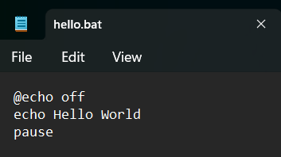

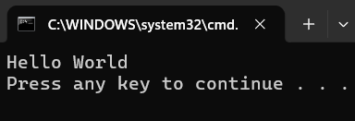

- Write a batch script to schedule to automatically back up important files and folders to a different location at a scheduled time.

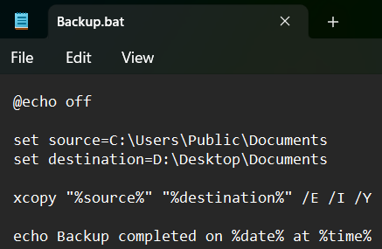

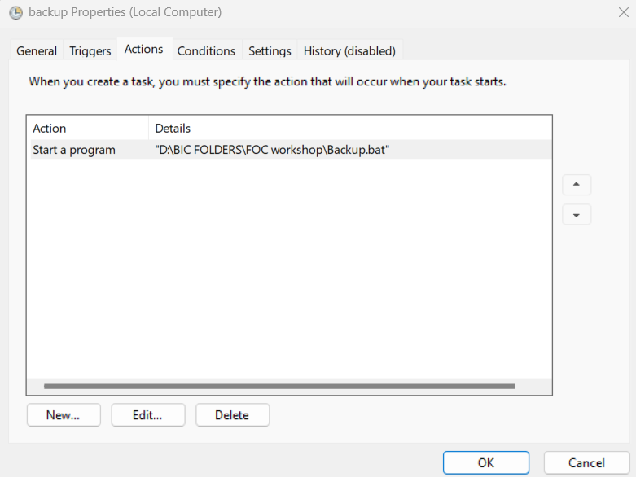
- Write a Windows batch script that automatically deletes temporary files and clears out the recycle bin to free up space on the hard drive.

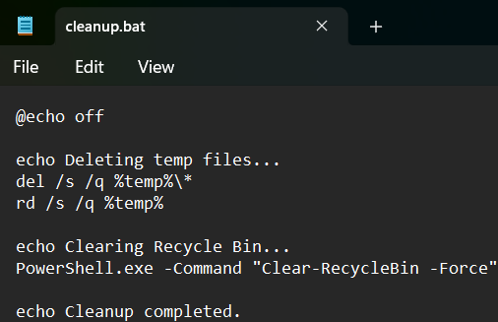

- Write a windows batch script that can be run to diagnose and troubleshoot common network issues
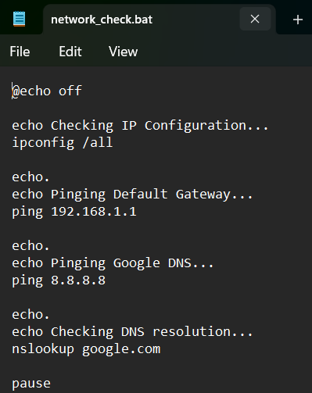
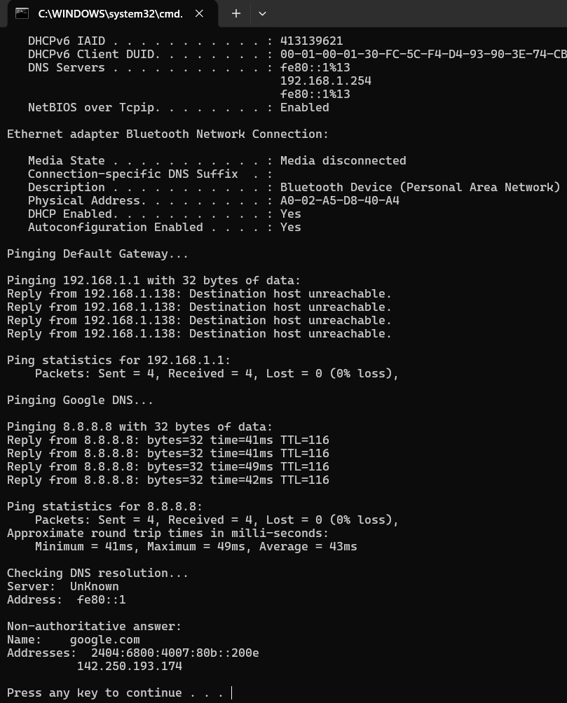

- Write a batch script that can be scheduled to shut down the computer at a specific time (using WINDOWS TASK SCHEDULER).



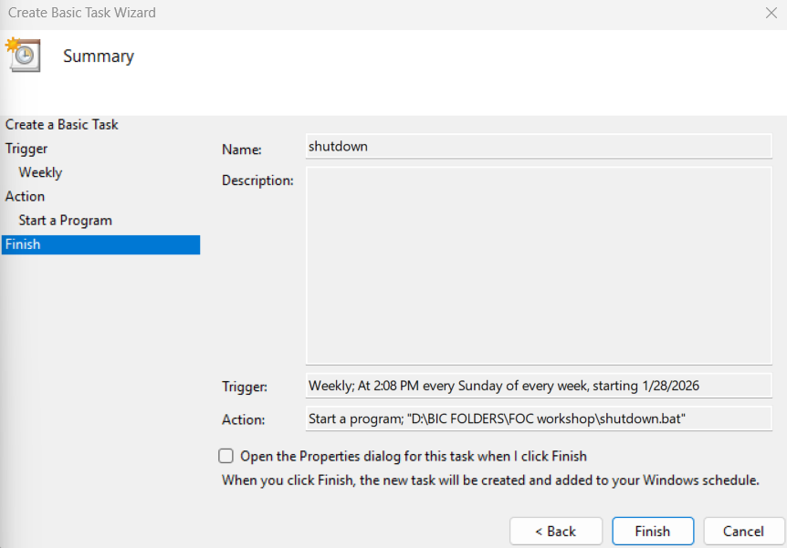

- Copy the following script Save this and run this in the Downloads directory or any directory you want.
@echo off
for %%a in (".\*") do (
if "%%~xa" NEQ "" if "%%~dpxa" NEQ "%~dpx0" (
if not exist "%%~xa" mkdir "%%~xa" (
move "%%a" "%%~dpa%%~xa\"
)
)
)

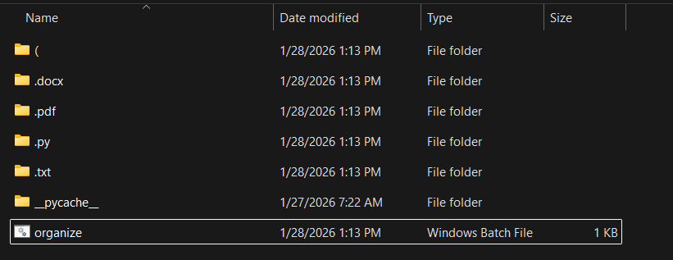

What does the above script do? Elaborate on your answer.
The given batch script automatically organizes all files in the current directory by grouping them into folders based on their file extensions. When the script runs, it scans every file in the directory and checks whether the file has an extension. For each file with an extension, the script creates a folder named after that extension if such a folder does not already exist. The file is then moved into its corresponding extension-based folder. The script also ensures that the batch file itself is not moved while the operation is performed. As a result, the directory becomes neatly organized, with files separated into folders such as .txt, .jpg, .pdf, and others, improving file management and reducing clutter.

